EHR COMPARISON
REPORT

RAMYA REDDY BAAPATHU
10/05/2024

Ramya reddy baapathu
Data Scientist,
To,
Chief Information Officer
Respected Sir,
Subject: Comparative Analysis of two EHR Systems
INTRODUCTION:
An electronic health record (EHR) is the systematized collection of patients and population electronically stored health information in a digital format
Meditech EHR:
Strengths:
1. User-Friendly Interface: This is so arithmetically foundational in the design of Meditech that most customers says its user-friendly functions. Its user interface is simple, and this makes healthcare professionals easily adapt to the system. It can also mean that the application is more user-friendly, there is less room for error when using it, and the processes are streamlined.
2. Customizable: The feature of customization is incorporated in the system at a very high level in such a way that it enables the healthcare provider to customize the EHR as per the requirements of their healthcare facility.
3. Integration Capabilities: One is that communication with other health systems, such as the laboratory and imaging system, works well. Interoperability of patient data guarantees that the patient data can be accessed by various departments, hence increasing the efficiency of patient care.
4. Training and Support: It comprises such things as training routines, reference material, and customer care, which assist the users in utilizing the functions offered by the system optimally while solving potential problems.
Weaknesses:
1. Cost: Ideally, it can be costly to the parties involved and also may take some time to be completed. The numerous options and additional forms and functions cost more, and that might be a problem for less equipped and small hospitals or those with not-so-large budgets.
2. Complex Data Extraction: It is not easy to extract data for research, further analysis, or some other higher form of usage with Meditech. Many parameters are adjustable, and the increased level of tuning might be complemented with other tools to utilize for data extraction and analysis.
3. Longer Implementation Time: The major weakness of Meditech is that because of its flexibility, it has a longer time to be implemented. This long time it might take for the system to reach its setup period may considerably slow down the system usage to its optimal capacity in an organization.
Greenway health/ Intergy EHR:
Strengths:
1. Advanced Analytics: Intergy possesses excellent analytical functions, primarily in terms of the conveyed data. It also has features such as data analysis tools and the ability to build models, which would be comforting for hospitals since they would be able to base their decisions on the results derived using the software, or it’s even useful for conducting research.
2. Cost-effective: It means that Intergy presents the offer in a form that is cheaper than the offer provided by Meditech. It offers basic functionalities at a reduced cost; therefore, it is convenient for hospitals that have limitations with their expenditures.
3. Ease of Data Extraction: It also entails making the system easier to extract data so that users only have to deal with data rather than the system. This is useful for research and for interfacing with machine learning tools since the preparation of the data imports is made considerably easier.
4. Faster Deployment: It can be understood that Intergy can be implemented more quickly than Miditech. Lastly, Intergy may be less time-consuming to deploy, and if your hospital requires a switch to a new EHR system quickly, then Intergy may be more beneficial.
Weaknesses:
1. User Interface: The overall idea of the interface of Intergy might be good, yet it will not be as friendly as Meditech’s. There may be more perceived complexity, which has implications on the initial performance and rate of adoption. 2. Limited Customization: The system gives out fewer choices of customization in comparison to Meditech. This may reduce its versatility to conform to certain requirements or even operations that might occur in distinctly varying departments.
3. Integration Issues: Intergy might also have difficulties in adopting existing systems or becoming compatible with other third-party applications. Other integrations may be needed for normal functioning in the case of higher levels of composite applications.
Comparison analysis:
To be able to decide in favor of Meditech or Intergy, both sides of the healthcare IT decision-making have to be considered. It would be ideal to choose Meditech, especially for your organization with many customizations needed since it shines in this area, great for complicated processes and shifting requirements in operations. It affords better integration with other existing third-party applications and health care systems so as to ease data transfers. Its support and training services are well developed to enhance ease in its implementation and use.
On the other hand, Intergy could be recommended if the issues of the costs are paramount to the organization, and here, Intergy brings out the best by providing general functionalities of EHR that are still cost-effective. It also stands high in clinical processes’ improvement and the enhanced report, especially in the management of patients as well as in the decision-making processes for operations. Also, if you decide that a cloud-based system is fitting for your IT plan, Intergy offers great deals in terms of its adaptability in infrastructural modularity and expandability.
When comparing EHR systems, I’m leaning towards Meditech based on several key factors:
Data Extraction: Meditech also provides a high level of customization and integration and, therefore, enhances the extraction of data for research and other machine learning applications. Due to the flexibility in data extraction, it proves suitable for complex data requirements, by which it can be easily tuned to the requirements.
Built-In Tools: Meditech also has a good API with external analytical tools and, therefore, good integrations, which can be useful for superior and varied business calculations. This is useful if your job involves using certain analytical techniques or software.
Ease of Use: Therefore, the simple graphical user interface and number of settings available in Meditech assist in the preparation and analysis of data. This can certainly help simplify management and the proper analysis of data. Intergy offers optimal reporting and analytical capabilities and is also economically advantageous; it may, however, be less customizable and integrated than Meditech. Intergy’s justifications for usage include its built-in reporting tools and the efficiency in the workflows, thereby making it easy to use in managing large amounts of data and enabling the acquisition of results quickly.
Conclusion: As pointed out earlier, identifying the most suitable EHR system is critical to providing the needed support in our hospital’s handling and sorting of data. Meditech and Intergy seem to be safe bets, and both have their perks. Meditech excels in aspects of customization and integration, while Intergy is well-appreciated for cost-effectiveness and rich reporting points. Ultimately, the best choice depends on organization specific needs, budget, and long-term goals.
I would like to organize a meeting to further elaborate on this report’s results to decide on which EHR system your hospital should install according to its requirements and business development strategy. Thank you for your attention, and I am waiting for our conversation.
Thankyou,
Ramya reddy Baapathu
Data Scientist

Appendix and Citations:
Based on few studies:
https://www.selecthub.com/ehr-software/intergy-vs-meditech-expanse/
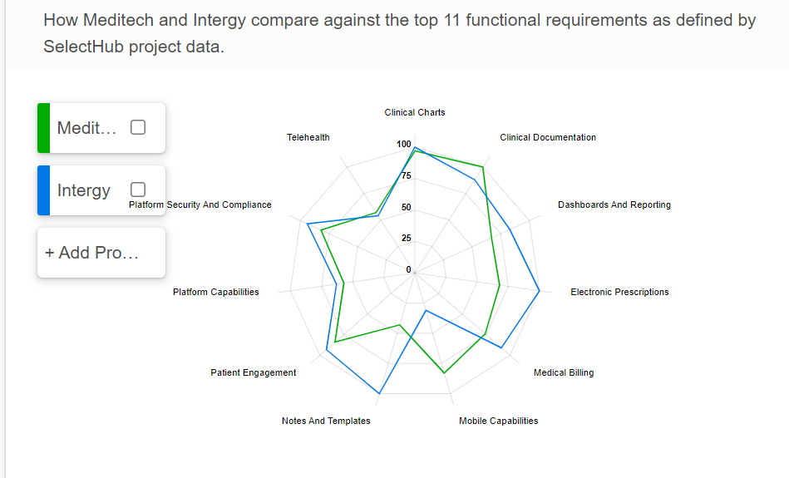
Summary:
- Meditech is stronger in areas like platform security and compliance, telehealth, and electronic prescriptions.
- Intergy performs better in medical billing, mobile capabilities, and patient engagement.
Citations:
- Introduction to EHR: Wikipedia - Electronic Health Record
- Meditech EHR System Overview: Meditech Official Site
Marsh K. MEDITECH EMR Software | Free Demo, Pricing, Latest reviews 2024 | EMRSystems. EMRSystems. Published August 26, 2024. https://www.emrsystems.net/meditech-ehr-software/

- Intergy EHR System Overview:
  - Greenway Health Official Site
  - EHR Guide - Greenway Health Reviews
  - Greenway Health: Pricing, reviews, and alternatives. https://www.tennr.com/resource/greenway-health-pricing-reviews-and-alternatives#:~:text=While%20Greenway%20Health's%20EMR%20excels,integration%20with%20other%20software%20systems.
- Comparison Reports and Analysis:
  - SelectHub Comparison
  - Industry Analyst Reports
- ChatGPT Prompt for Analysis: “Compare Meditech and Intergy EHR systems in terms of strengths and weaknesses, integration capabilities, and data extraction for research.”
5. Additional Notes
- Ensure that any implementation or customization of EHR systems is aligned with your organization's specific needs and long-term strategic goals.

